DSA1605 | Knowledge Engineering and Data Science

Lab Session

1.A class consists of 40 students who have secured different grades in an examination. The grades are classified as F, E, D, C, B, A, and S, where F represents the lowest grade and S represents the highest grade.
The number of students who secured each grade is given below.
Grade Number of Students
F 3
E 4
D 5
C 8
B 9
A 7
S 4
Total 40
Develop a Python program to perform the following tasks:
1. Store the grades and corresponding number of students in suitable data structures.
2. Draw a pie chart to represent the percentage distribution of students across the seven grades.
3. Display the grade labels and percentage values on the pie chart.
4. Draw a bar chart to compare the number of students who secured each grade.
5. Label the X-axis as Grades and the Y-axis as Number of Students.
6. Display the exact number of students above each bar.
7. Add suitable chart titles, legends, and axis labels.
8. Identify the grade secured by the maximum and minimum number of students.
9. Display the percentage of students who secured grades A and S combined.

AIM:

To develop a Python program using Google Colab to visualize the distribution of students across different grades using pie charts and bar charts, display the percentage and number of students for each grade, identify the grades with the maximum and minimum number of students, and calculate the combined percentage of students who secured grades A and S.

PROCEDURE:
- Open Google Colab and create a new Python notebook.
- Import the matplotlib.pyplot library.
- Store the grades and corresponding student counts in lists.
- Calculate the percentage distribution and draw a pie chart.
- Draw a bar chart with axis labels and student counts above each bar.
- Identify the maximum and minimum grades using max() and min().
- Calculate the combined percentage of students who secured grades A and S.
- Execute the program and observe the output charts and results.

PROGRAM:

import matplotlib.pyplot as plt

# 1. Store grades and number of students
grades = ['F', 'E', 'D', 'C', 'B', 'A', 'S']
students = [3, 4, 5, 8, 9, 7, 4]

# Calculate total students
total = sum(students)

print("GRADE DISTRIBUTION")
print("------------------")
for grade, count in zip(grades, students):
percentage = (count / total) * 100
print(f"Grade {grade}: {count} students ({percentage:.2f}%)")

# 2. Draw Pie Chart
plt.figure(figsize=(8, 6))

plt.pie(
students,
labels=grades,
autopct='%1.1f%%',
startangle=90
)

plt.title("Percentage Distribution of Students by Grade")
plt.legend(grades, title="Grades", loc="best")
plt.show()

# 3. Draw Bar Chart
plt.figure(figsize=(8, 6))

bars = plt.bar(grades, students, color='skyblue', edgecolor='black')

plt.xlabel("Grades")
plt.ylabel("Number of Students")
plt.title("Number of Students in Each Grade")
plt.xticks(grades)
plt.ylim(0, max(students) + 2)

# Display exact number above each bar
for bar in bars:
height = bar.get_height()
plt.text(
bar.get_x() + bar.get_width() / 2,
height + 0.1,
str(int(height)),
ha='center',
va='bottom'
)

plt.legend(["Number of Students"])
plt.show()

# 4. Identify maximum and minimum grades
max_count = max(students)
min_count = min(students)

max_grades = [
grades[i] for i in range(len(grades))
if students[i] == max_count
]

min_grades = [
grades[i] for i in range(len(grades))
if students[i] == min_count
]

print("\nRESULTS")
print("-------")
print(f"Maximum students: Grade {', '.join(max_grades)} ({max_count} students)")
print(f"Minimum students: Grade {', '.join(min_grades)} ({min_count} students)")

# 5. Calculate combined percentage of A and S
a_s_students = students[grades.index('A')] + students[grades.index('S')]
a_s_percentage = (a_s_students / total) * 100

print(f"Students with grades A and S combined: {a_s_students}")
print(f"Combined percentage of A and S: {a_s_percentage:.2f}%")

OUTPUT:

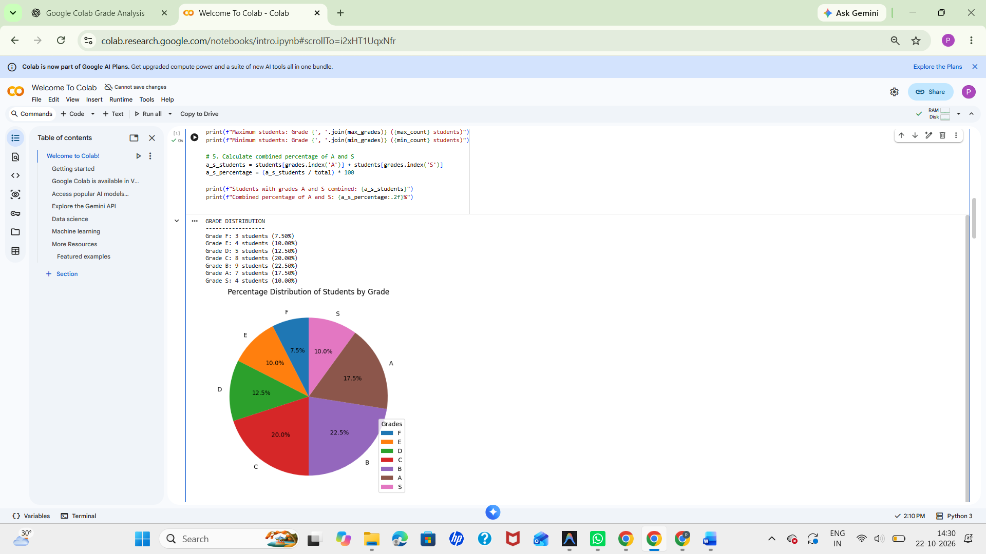

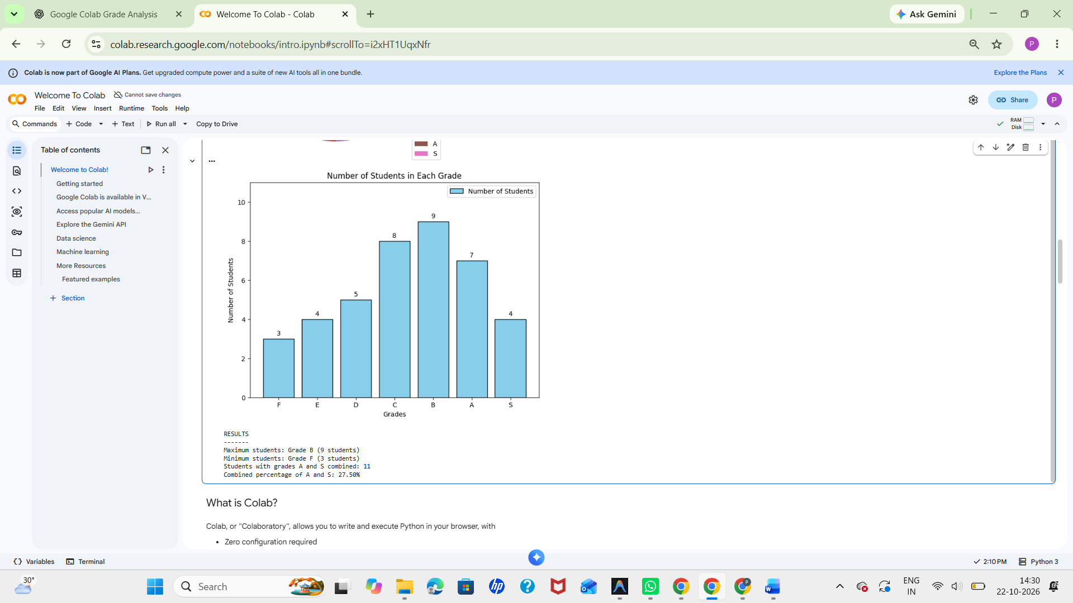

2) Semantic Network Using NetworkX
Aim: To represent concepts and labeled relationships as a directed semantic network.
Software Required: Python 3.x and NetworkX (install with: pip install networkx)
Procedure / Algorithm
1. Create a directed graph.
2. Add concepts as nodes implicitly through edges.
3. Add labeled relationships.
4. Display each relationship.
Program
import networkx as nx

G = nx.DiGraph()
G.add_edge("Dog", "Mammal", relation="is-a")
G.add_edge("Mammal", "Animal", relation="is-a")
G.add_edge("Dog", "Tommy", relation="has-instance")

print("Semantic Network Relationships:")
for source, target, data in G.edges(data=True):
print(source, "--", data["relation"], "-->", target)
Sample Input
Concepts and relations are predefined in the program.
Expected Output
Semantic Network Relationships:
Dog -- is-a --> Mammal
Dog -- has-instance --> Tommy
Mammal -- is-a --> Animal
Result: The semantic network represented concepts and their relationships.

AIM
To represent concepts and their labeled relationships as a directed semantic network using Python and the NetworkX library.

PROCEDURE
- Import the NetworkX library.
- Create a directed graph using nx.DiGraph().
- Add concepts and labeled relationships using add_edge().
- Display each relationship using a for loop.
- Execute the program and observe the output.

PROGRAM:

import networkx as nx

# Create a directed graph
G = nx.DiGraph()

# Add concepts and relationships
G.add_edge("Dog", "Mammal", relation="is-a")
G.add_edge("Mammal", "Animal", relation="is-a")
G.add_edge("Dog", "Tommy", relation="has-instance")

# Display relationships
print("Semantic Network Relationships:")
for source, target, data in G.edges(data=True):
print(source, "--", data["relation"], "-->", target)

OUTPUT:

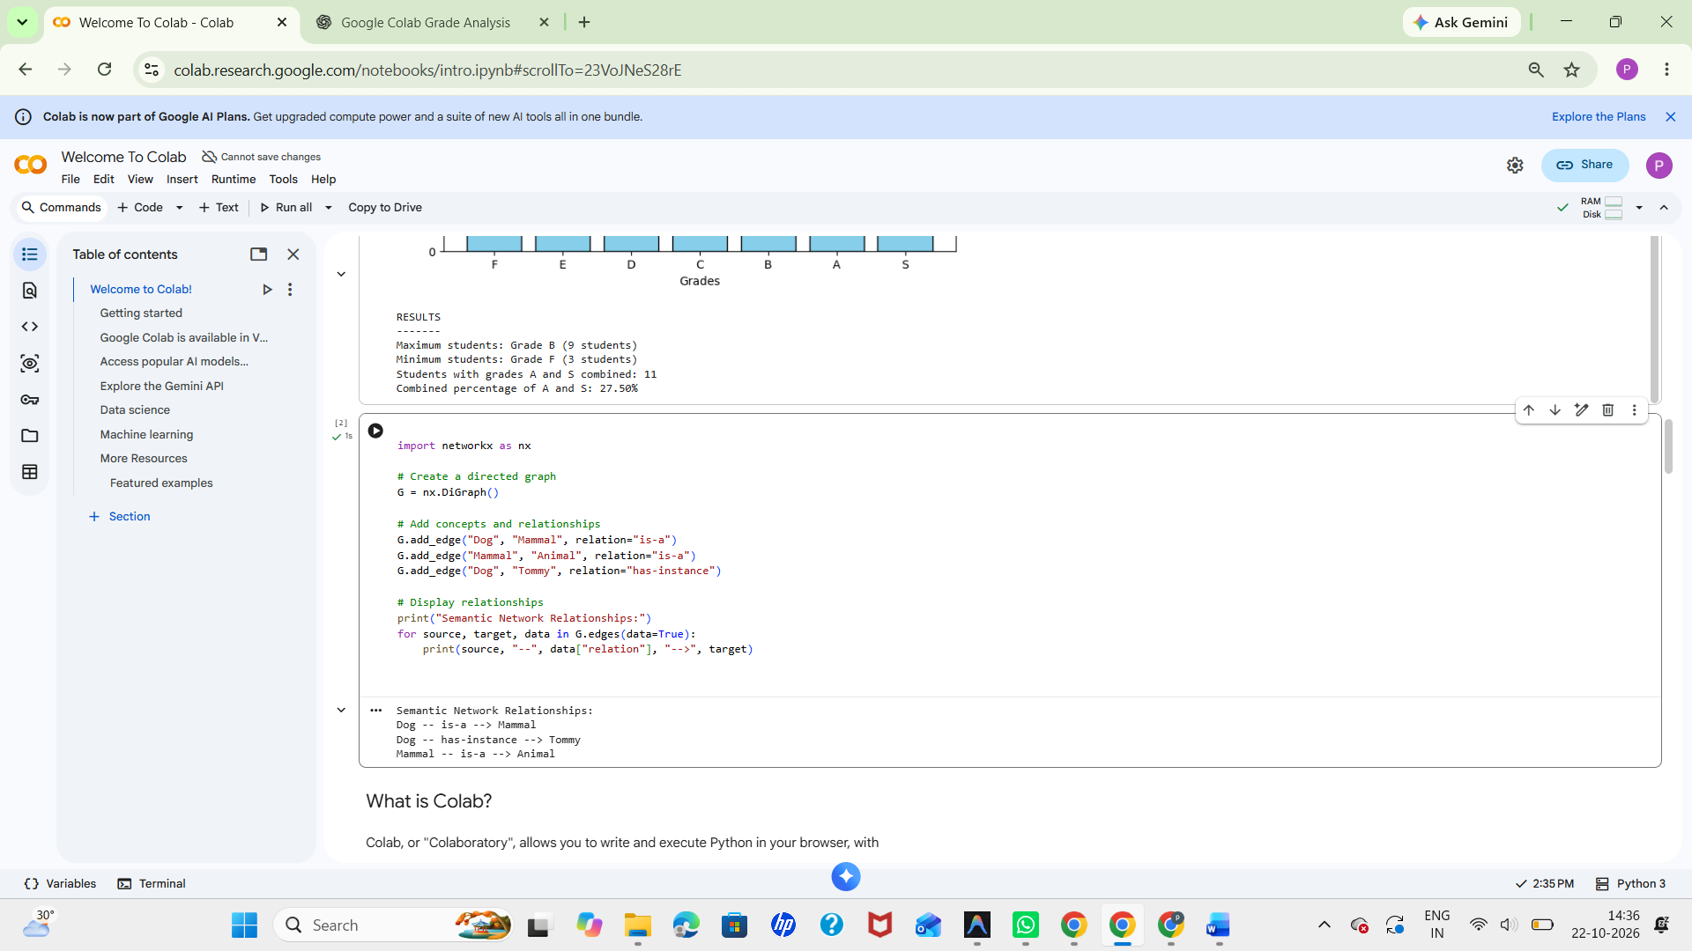

3) Frame-Based Knowledge Representation
Aim: To represent an object as a frame containing slots and values.
Software Required: Python 3.x
Procedure / Algorithm
1. Create a dictionary to represent a frame.
2. Use keys as slots and values as slot values.
3. Display the frame.
Program
vehicle = {
"class": "Vehicle",
"brand": "Toyota",
"fuel_type": "Petrol",
"wheels": 4,
"color": "White"
}

print("Vehicle Frame")
for slot, value in vehicle.items():
print(slot, ":", value)
Sample Input
Frame values are predefined in the program.
Expected Output
Vehicle Frame
class : Vehicle
brand : Toyota
fuel_type : Petrol
wheels : 4
color : White
Result: The vehicle was represented using slots and their corresponding values.

AIM:

To represent an object using frame-based knowledge representation with slots and their corresponding values in Python.

PROCEDURE:

- Create a dictionary to represent the frame.
- Define slots as keys and their values in the dictionary.
- Use a for loop to access the slots and values.
- Display the frame and observe the output

PROGRAM:

vehicle = {
"class": "Vehicle",
"brand": "Toyota",
"fuel_type": "Petrol",
"wheels": 4,
"color": "White"
}

print("Vehicle Frame")
for slot, value in vehicle.items():
print(slot, ":", value)

OUTPUT:



